## Overview

* Course focuses on 3 manipulative tactics
  + Misleading graphs - based on the First Draft course
  + Anecdotes - from the 26 tactics graph + not widely studied
  + False comparisons - from the 26 tactics graph + not widely studied
* Delivery focuses on being as effective as possible
  + Interactive
  + We use a single treatment (the most effective we could come up with) and control group
* Outcomes focus on ability to identify tactics and on sharing behavior online and offline
  + We took into account your comments about not just online behavior and this was the best we could come up with that is likely less affected by the contexts of the post examples
  + We use two tests, one prior and one after the intervention to increase our power
* Example posts for testing
  + Include true and misleading posts (focusing on each tactics)
  + We have comparable pairs (will randomize who sees which as pre and post test)

## Tactics Mini Course

### [Intro & Anecdotes]

There are **over 26 different tactics** used to create manipulative content!

We’ll now show you how three of them look.

*Next page*

💬 Have you ever had a friend rave to you about something like a restaurant or a movie — only to be disappointed when you tried it yourself?

* Yes
* No
* I’m not sure

*Next page*

When someone tells you about their experience with something, that story is called an anecdote, and they aren’t always reliable.

⁉️ How does that work?

⚠️ The danger of anecdotes is that they assume what’s true for one person should be true for everyone. Here’s an example:

Suppose a friend told you: “My cousin is a really fast sprinter, and only buys shoes with thin soles. So if you want to run faster, you should buy shoes with thin soles, too!”

🧐 What do you think about this example?

* This is great advice!
* This anecdote could be misleading

*Next Page*

[Maybe.] / [Yes!] It’s possible that there’s more information about the cousin that we could be missing. Maybe their cousin is a fast sprinter because they do a lot of training.

⚠️ This means that we need to be careful about anecdotes because they could lead us to the wrong conclusion. In fact, using anecdotes is a common tactic to persuade and manipulate.

🍒 Anecdotes are often cherry-picked because something unusual happened. You don’t hear all the times that something didn’t work, because those stories aren’t as interesting.

🧠 Humans are also more likely to remember personal stories, even if they aren’t as accurate.

Here are some other examples. Which of these examples do you think could be using anecdotes to manipulate their audience?

* An advertisement where a celebrity tells you about their great experience with a new product
* A politician telling you about a conversation they had with a voter
* A friend telling you about how much money they made investing in a new business

*Next Page*

All of these could be examples of using anecdotes for manipulation! None of these examples are giving you information that something is true all the time. They’re telling you a story about one person’s specific experience.

👀 When confronted with an anecdote, take a moment to reflect on whether there may be reasons that it doesn’t apply to you.

You have mastered the tactic of anecdotes!

### [False comparisons]

💬 Do you know how to finish this phrase:

“Stop comparing apples to…” ?

* apples
* cars
* pies
* trees
* oranges

*Next page*

That’s correct! / That’s actually not quite right. The phrase, comparing apples to oranges, refers to comparing two things, food related or otherwise, that share obvious common characteristics, while being ultimately different.

In the case of apples and oranges, it is obvious that while they are both fruits, they are quite different in many aspects.

⚠️ The danger is when comparisons are made between more complex things in order to manipulate the reader to jump into conclusions.

🧐 Can you think of comparisons that could be used to manipulate? Select the pairs of things from the list below that you think could be used to make manipulative conclusions

* Two groups of people on the same diet
* Addictions to alcohol or to shopping
* Attending public school today or 50 years ago
* Two patients with the same disease
* Running the country or running a company
* Buying a lottery ticket or buying a stock
* Two patients having fever

*Next page*

You are right! And in fact, all of the options listed earlier refer to things that are similar in some aspects while being not exactly same in other regards. Such pairs of things can be used to manipulate by making a misleading or false comparison.

Here is an example of this:

“Car insurance companies reward good behavior: no claims = better rates. Why not have health insurance companies reward good behavior too?”

Car insurance and health insurance companies both provide insurance that can save you large amounts of $$$ in case things go wrong. However, there are important differences between the two. For example, medical insurance covers “maintenance” like regular checkups and preventative care. Additionally, costly medical concerns often arise due to causes beyond the “fault” of the individual.

This is to show that examples like the above are complex cases. Simplifying them using a false comparison disregards important details and can be used to manipulate.

Let’s see another example:

“Running the country is no different from running a business. It’s irresponsible to increase national debt.”

What do you think about the above statement?

* It is not manipulative, no complexities are omitted
* It is manipulative, complexities are omitted

*Next page*

That’s correct / not quite. Both the Government and companies have balance sheets, revenues and expenses. However, the goal of a company is to maximize profits, which is not the primary objective of the Government. Instead, the Government has significantly more complex objectives.

👀 When confronted with a simple looking comparison, take a moment to think carefully and ask whether any complexities have been omitted.

You have mastered the tactic of false comparisons!

### [Graphs]

💬 Do you know how to finish this saying:

As the old saying goes: “A picture can tell

* an image
* colors and shapes
* a thousand words
* no words

*Next page*

That’s correct! / That’s actually not quite right. A picture can tell a thousand words, and that’s also true for graphs and diagrams. 📈📊 These can make information look more official.

⚠️ The danger is that graphs can be easily presented to be manipulative.

🧐 Can you think of any ways to make a graph manipulative? Select all the options below that you think would make a graph manipulative

* Use incorrect numbers
* Draw the graph incorrectly
* Change an axis
* Truncate an axis
* Use a confusing graph type
* Add distracting elements
* Omit the labels
* Add unnecessary images
* Use confusing colors

*Next page*

You are right! And in fact, all of the options listed earlier include manipulation tactics.

Here is an example of truncating the vertical axis

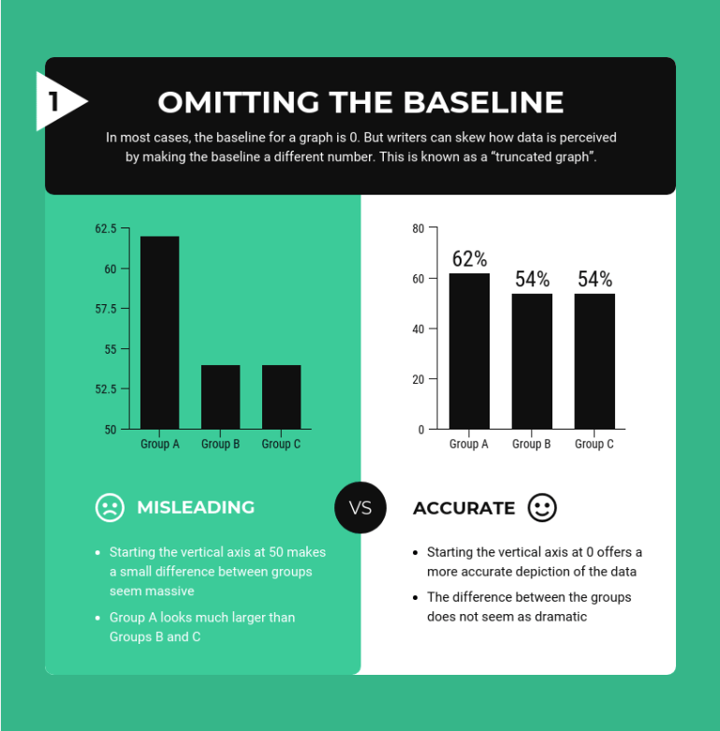

If the vertical axis doesn’t start at zero, small differences may seem much bigger.

Stretching out the vertical axis can have the opposite effect, as you can see it below:

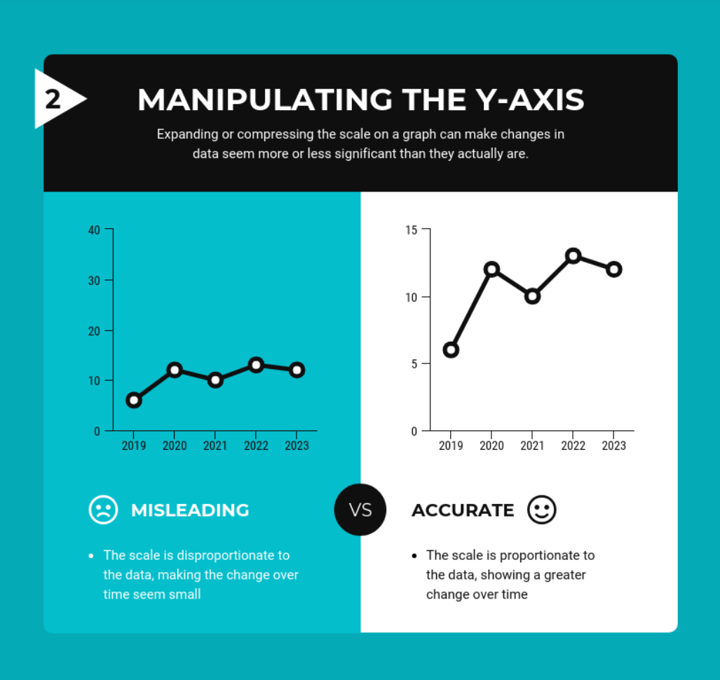

Using the wrong kind of graph can be just as misleading:

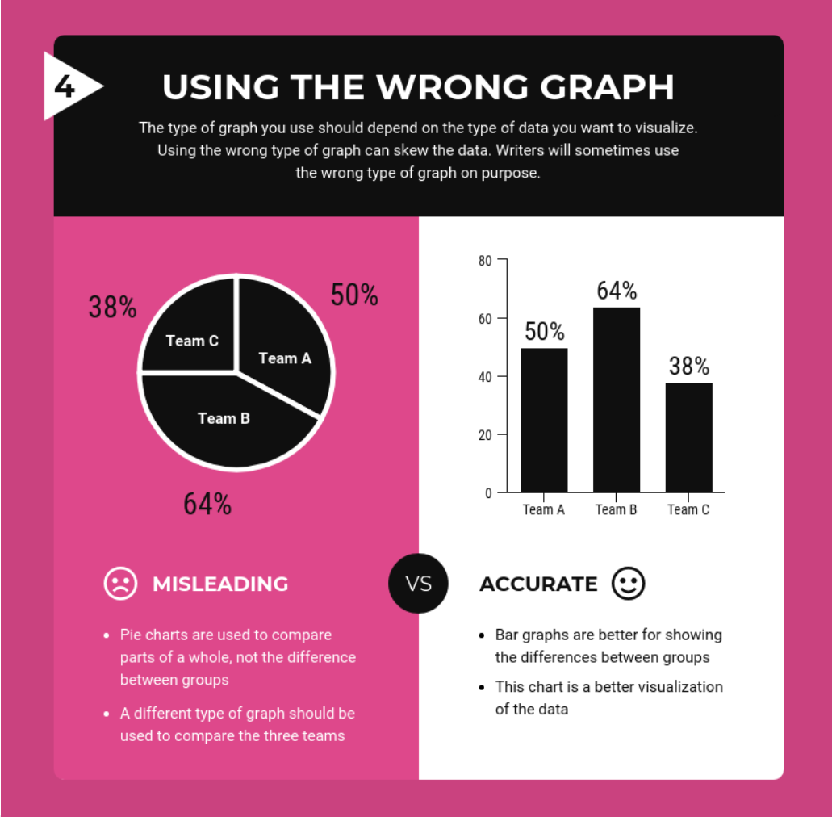

Let’s look at a real example. What do you think about the following graph?

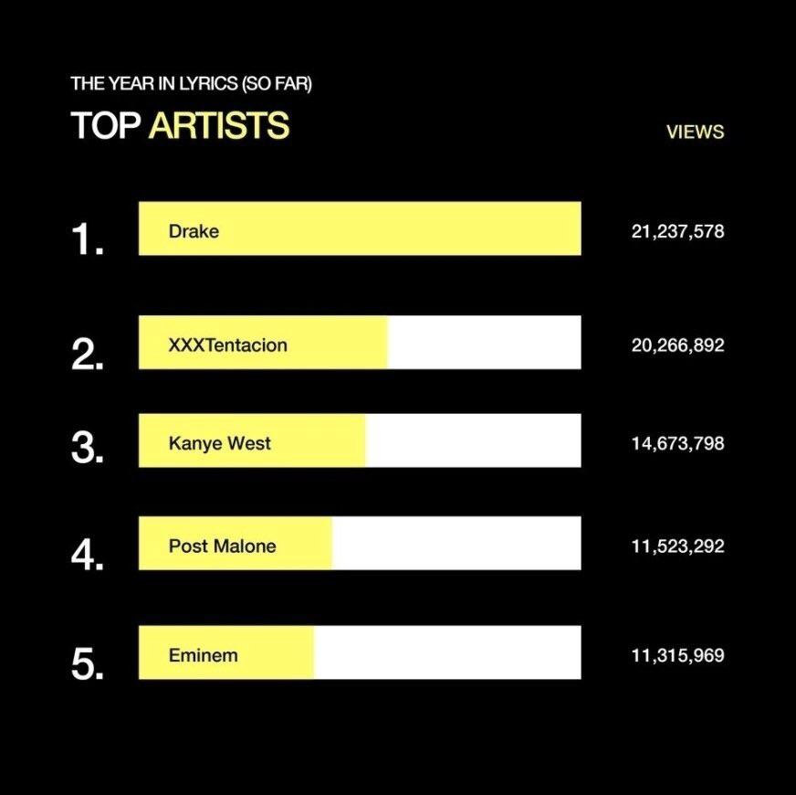

* Drake is so much better than everyone else
* The bars seem a bit off

*Next Page*

Let’s take a more careful look / That’s right! Drake doesn’t look that far ahead of the competition if the bars are plotted correctly.

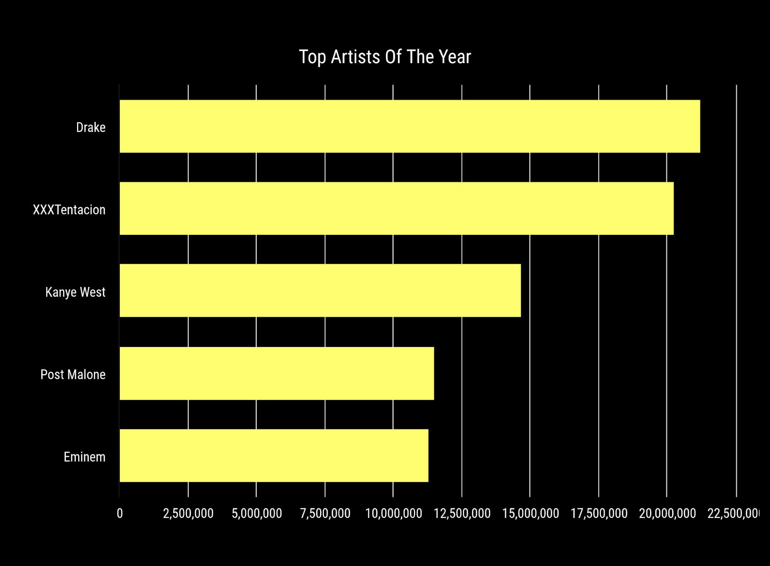

👀 When confronted with a graph or diagram on social media, be sure to look it over carefully and check where the data comes from.

You have mastered the tactic of manipulating graphs and diagrams!

## Outcome Questions

[Post] → this is replaced by one of 6 example posts for each of the pre and the post questions

1. How manipulative do you find this post?

Not at all Very

1 2 3 4 5 6

2. [Show only if 4-6 selected]:

Which aspect of the post is manipulative? (Please select all that apply)

* Manipulative graph
* Evidence taken out of context
* False comparison
* Misleading anecdote
* Other:

3. Behavior questions

* Would you like to share this post on social media?

Definitely not Definitely yes

1 2 3 4 5 6

* Would you want to talk to others about this information offline?

Definitely not Definitely yes

1 2 3 4 5 6

## Posts for testing

Manipulative - Anecdote

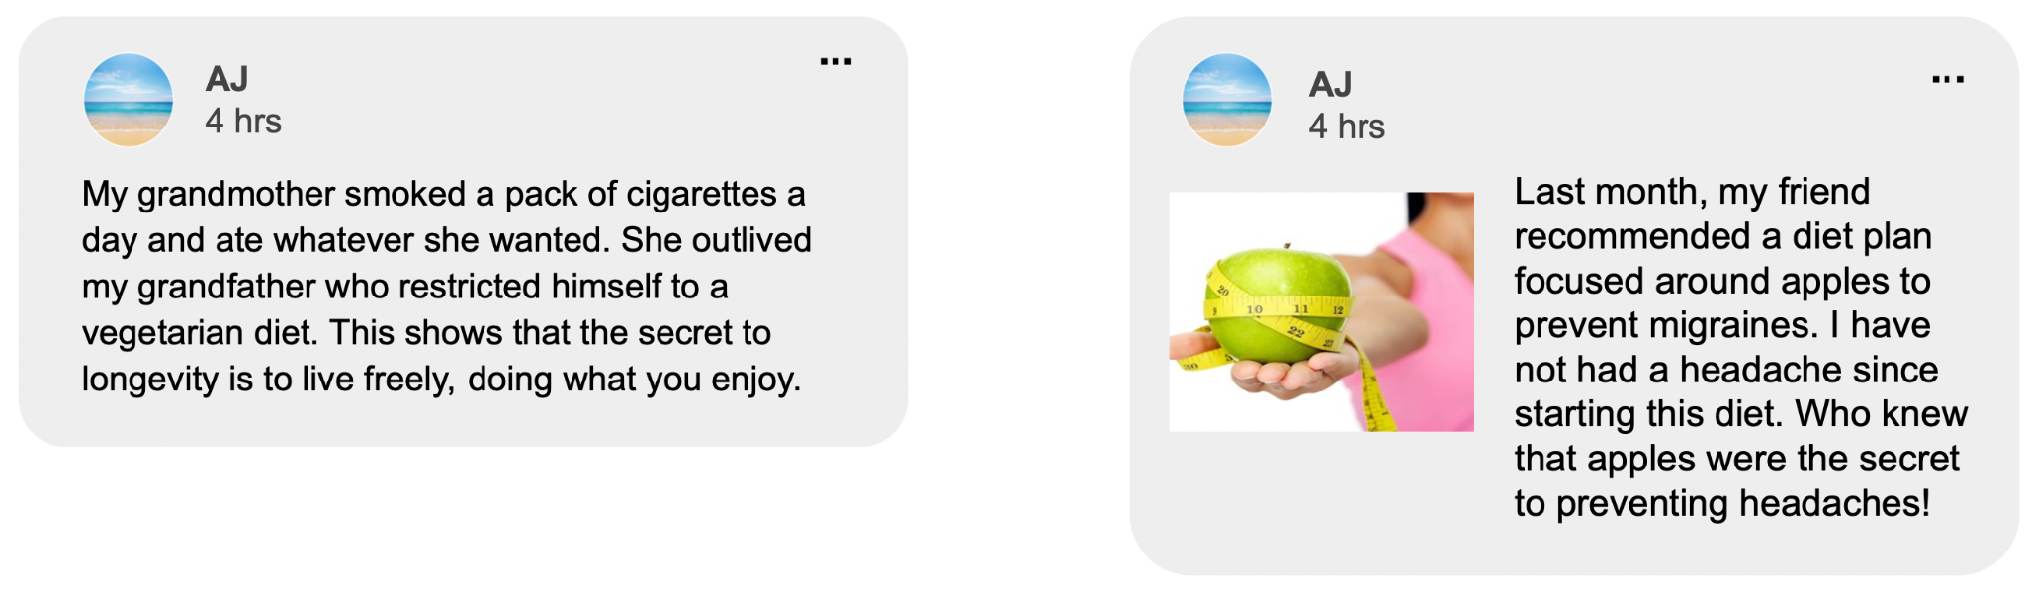

Manipulative - False comparison

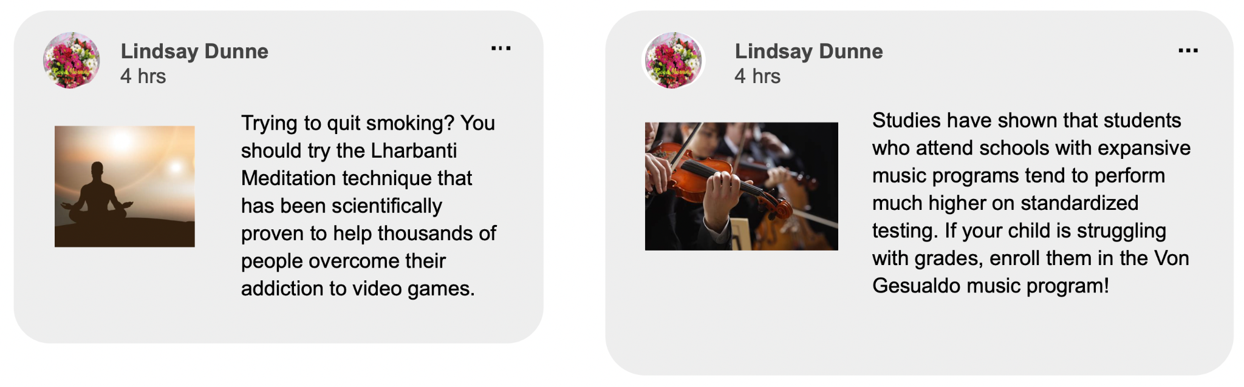

Manipulative graph

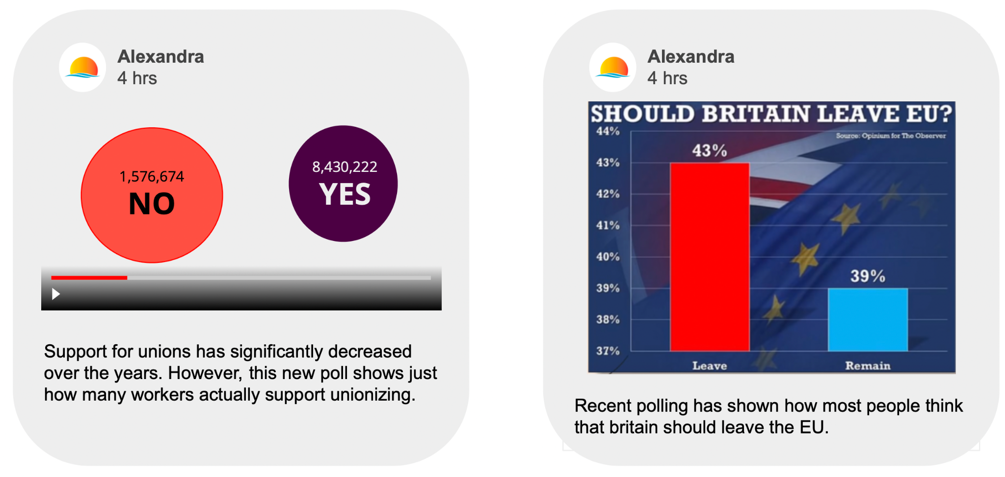

Manipulative combined (with non-manipulative graph)

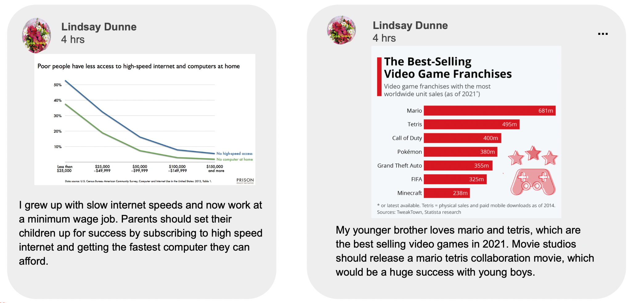

Truths:

